**Route optimization:**

**GUI:**

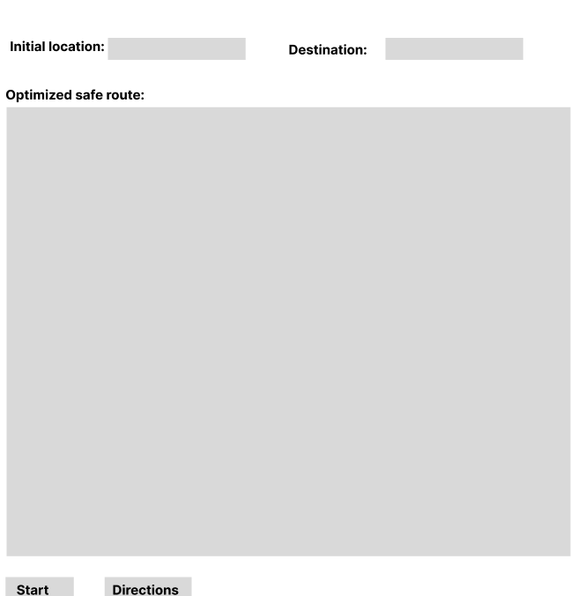

**Use case specification:**

|  |  |  |  |
| --- | --- | --- | --- |
| Use Case ID: | 3 | | |
| Use Case Name: | Route Optimization | | |
| Created By: | K. Meher Sai, S Manikanta | Last Updated By: | K. Meher Sai, S Manikanta |
| Date Created: | 18th February 2024 | Date Last Updated: | 18th February 2024 |

|  |  |
| --- | --- |
| Actors: | Driver |
| Description: | Route optimization from initial to destination based on traffic updates and incident-aware routing. |
| Preconditions: | The user should login to the system. |
| Post conditions: | The optimized route map will be continuously updated as the location of user through GPS is tracked. |
| **Normal Flow:** | 1. The input location is filled by the current location of user or user can choose an initial location. 2. User enters destination to go. 3. If user enters start, then live navigation is displayed[A-1]   Else just the route on the map is displayed. |
| **Alternative Flows:** | A-1: If the destination is not entered, the user will be prompted to enter the destination or If stop button is clicked during live navigation it gets stopped. |
| Exceptions: | If internet connection is not there then live navigation is stopped. |
| Includes: |  |
| Priority: | High |
| Frequency of Use: | High |
| Business Rules: |  |
| Assumptions: | - |

**Activity Diagram:**

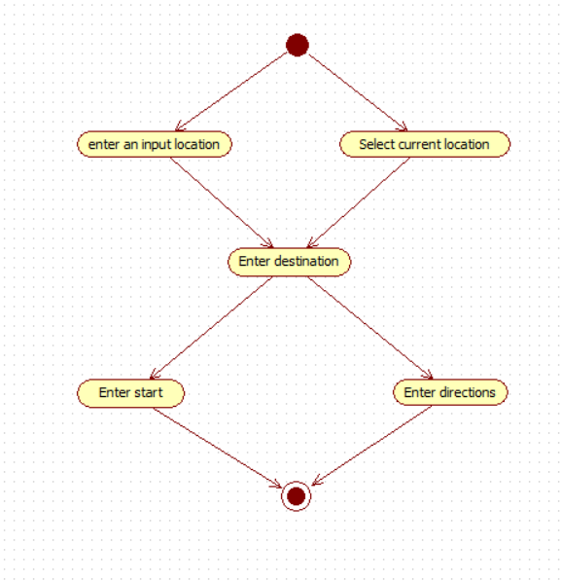

**Sequence Diagram:**

Nouns are user, location, map.

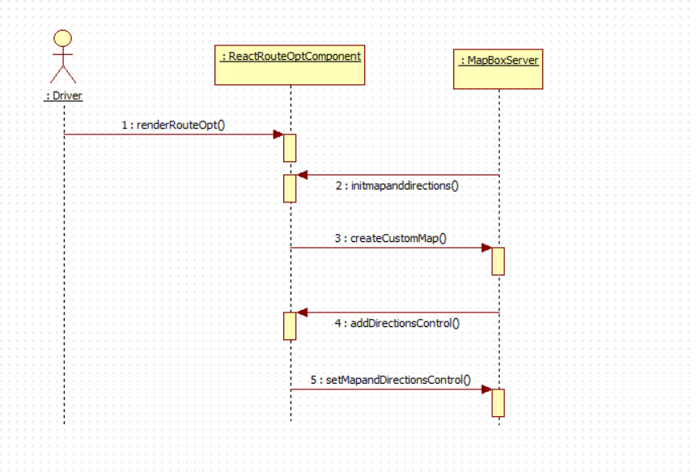

**Implementation:**

Using the **MapBox Directions API** it provides optimal route based on real time traffic data from the given initial point to destination.

The frontend UI is built by **React JS.**

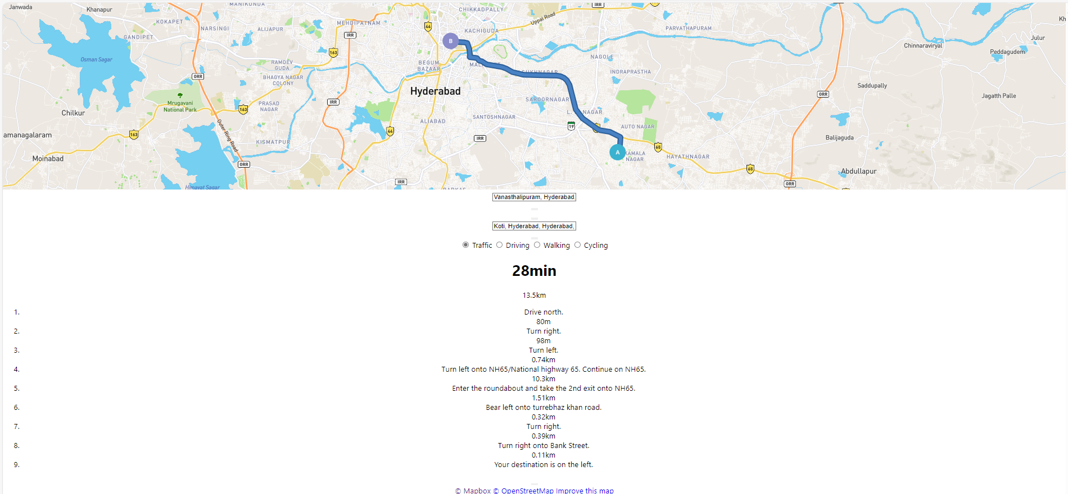

All the directions are provided and the total trip time is calculated.

**More features to be added:**

1. Live navigation
2. Improving GUI design.